|  |  |
| --- | --- |
| **Ex No: 2**  **Date: 14/08/2024** | **Planar Data Distribution Analysis using Logistic Regression** |

**Objective:**

To build a logistic regression classifier to classify the points in a planar dataset and analyze the decision boundary formed by the model.

**Descriptions:**

Binary classification is the task of classifying elements of a given set into two groups based on a certain criterion. Logistic regression is a supervised learning algorithm widely used for binary classification problems. The aim is to develop a classifier that can effectively separate the two classes of data points in the planar distribution.

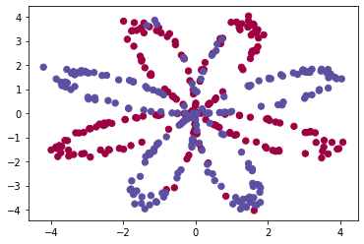

In this exercise, we have a 2D dataset where each data point belongs to one of two classes. The logistic regression model will be trained to classify these points, and we will observe the decision boundary that the model forms. The dataset consists of two features (x1 and x2) that define the position of each point in the plane.

**Model:**

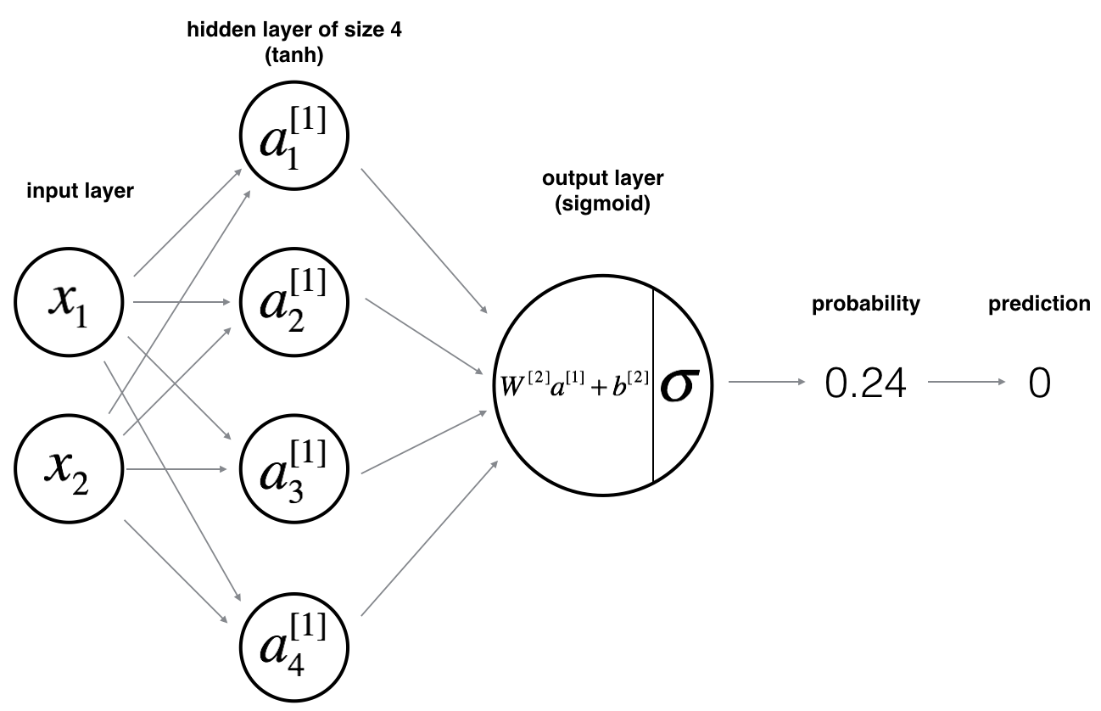

**Building the parts of algorithm**

The implementation of the logistic regression classifier involves the following key steps:

1.Define the Model Structure

2. Initialize Model Parameters

3. Forward Propagation

4. Calculate the Cost Function

5. Backward Propagation

6. Gradient Descent

7. Iterate the Process

**GitHub Link:**

**https://github.com/Mithungowda6666/Logistic_Regression_session-2/tree/main/Planar_data_set%20_session%202**